Structure and Functions of the Eye
WORD BANK
Lens Cornea Iris Pupil
Optic Nerve Retina

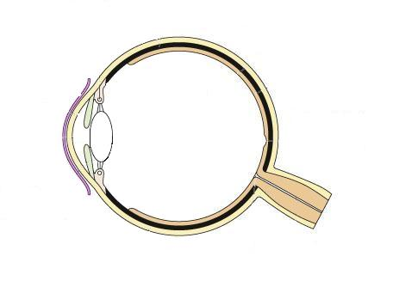
Part 1: Structure- Label each part of the eye found in the word bank, using arrows.

Part 2: Functions- Fill in the table with the function of each part of the eye
Part | Function  (Be sure to use 1-2 complete sentences for each!)
Lens
Cornea
Iris
Pupil
Optic Nerve
Retina

