Slinky Wave Lab
Background
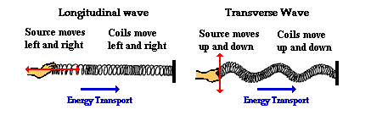
A wave can be described as an energy disturbance that travels through a medium from one location to another. Waves, simply put, are energy moving from one place to another. As the wave moves through the medium (water, slinky, air), energy is being passed from one particle to the next. Waves occur around us every day. Some common places we experience waves are in sound, light, water, and earthquakes.

In addition to being a great toy, the Slinky is an excellent device for creating and studying waves. A slinky can easily demonstrate the two basic types of waves, longitudinal and transverse. In a longitudinal wave the particles move parallel to the direction the wave is moving. In a transverse wave the particles move at right angles to the direction of wave travel.
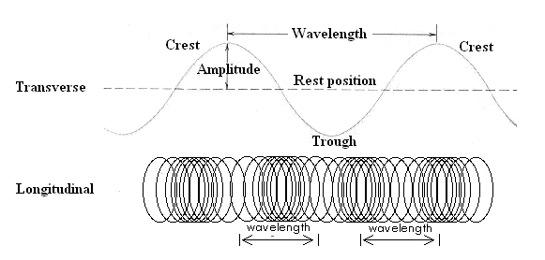

There are three basic characteristics used to describe waves.
- Frequency – The number of waves produced in a given time period. This is usually measured in waves per second called Hertz (Hz).
- Wavelength – The length of a wave. This can be measured easily from crest to crest or from trough to trough.
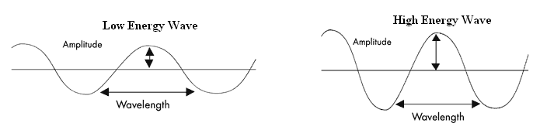
- Amplitude – The height or depth of a wave. The amount of energy carried by a wave is related to amplitude. A high energy wave is characterized by high amplitude; a low energy wave by low amplitude.
Materials:
Slinky, meter stick, pencil

Purpose:
The purpose of the lab is to study the types of waves and their properties using a slinky.
Slinky Lab!

Procedure:
- Select a lab partner and gather the lab materials.
- On a smooth floor or the lab desk, stretch the slinky out between you and your partner.
(Caution – Do not over stretch the slinky!)

Part 1
- Send a single wave to your partner (see below).

- Observe what happens to the wave when it reaches your partner’s end. Observe the reflected wave.

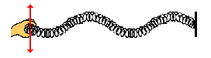
- Move one end of the slinky back and forth on the floor repeatedly (see diagram below). Observe what happens as you vary the rate at which your hand moves or vibrates.

Part 2

- Next create a series of waves by moving your hand towards and away from your partner (see the diagram below). Observe this wave and how it travels.

- Try pushing your hand toward and away from your partner faster. Observe the wave.

Analysis Questions

- Draw and Label a transverse and longitudinal wave.
Transverse Wave  (Be sure to label Crest, Trough, Amplitude, and Wavelength) | Longitudinal Wave  (Be sure to label Compression, Rarefaction, and Wavelength)
- Describe what happened to the frequency of the waves when you increased the rate of vibration (how fast your hand moved back and forth).

- Describe what happened to the wavelength when you increased the rate of vibration (how fast your hand moved back and forth).

- Describe the relationship between wavelength and frequency?

- For each wave produced during this lab, the individual spring coils did not actually travel from one end of the slinky to another. If the wave coils did not travel than what did? Be sure to explain.

