Amplitude, Wavelength and Frequency

Amplitude
As waves travel, they set up patterns of disturbance. The amplitude of a wave is its maximum disturbance from its undisturbed position. Take care; the amplitude is not the distance between the top and bottom of a wave.

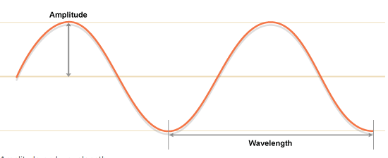

Wavelength
The wavelength of a wave is the distance between a point on one wave and the same point on the next wave. It is often easiest to measure this from the crest of one wave to the crest of the next wave, but it doesn't matter where as long as it is the same point in each wave.

Frequency
The frequency of a wave is the number of waves produced by a source each second. It is also the number of waves that pass a certain point each second. The unit of frequency is the hertz (Hz). It is common for kilohertz (kHz), megahertz (MHz) and gigahertz (GHz) to be used when waves have very high frequencies. For example, most people cannot hear a high-pitched sound above 20kHz, radio stations broadcast radio waves with frequencies of about 100MHz, while most wireless computer networks operate at 2.4GHz.

Draw a transverse wave for each description. In your ISN, write a summary about what occurs as you increase/decrease each characteristic of a wave.
Wavelength
Increase | Decrease
Frequency
Increase | Decrease
Amplitude
Increase | Decrease

